Vet360 Addressing Validation Service

Onboarding Manual



January 2018

Department of Veterans Affairs

Office of Information and Technology (OI&T)

Revision History

1. The revision history cycle begins once changes or enhancements are requested after the document has been baselined.

| Date | Revision | Description | Author |
| --- | --- | --- | --- |
| 3/2019 | 1.4 | Updated Swagger Links to Kong | Amy Rosenthal – Vet360 Team |
| 02/2019 | 1.3 | Updated security requirements. Added validation key info | Vet360 Team |
| 12/2018 | 1.2 | Compiled information for two other services, GetCityStateProvince and the candidate address service | Halfaker |
| 11/2018 | 1.1 | Added information on new Vet360 rules for address and Missing Reference data (section 3.1 and update to 2.2.1 and 2.2.2) | Halfaker |
| 06/2018 | 1.0 | Initial document | Halfaker |

Artifact Rationale

An Onboarding Manual is an end-user document for all OI&T software releases. The intended audience for this document are partners who wish to integrate with the Address Validation Service (AVS) to be able to validate domestic and international addresses consistently across the enterprise. It provides sufficient technical information about the software for developers and technical personnel to operate and maintain the software with only minimal assistance from Product Support staff.

Contents

1. Introduction 3

1.1. Purpose 3

1.1.1. Disclaimers 3

1.1.2. External References 3

1.2. Swagger API Documentation 4

1.2.1. Security Requirements for Access 4

1.2.2. Database Requirements 5

2. Endpoints 6

3. Address Validation 7

3.1. Input 7

3.1.1. Fields 7

3.1.2. Input Requirements 7

3.2. Output 8

3.2.1. Error Messages 8

3.2.2. Missing Reference Data 8

4. GetCityStateProvince 8

4.1. Input 8

4.2. Output 8

4.2.1. Error Messages 9

5. Candidate Address 9

5.1. Input 9

5.2. Output 9

5.2.1. Error Messages 9

6. Additional Information 9

6.1. Vet360 Address Validation Rules 9

6.2. Address Override Indicator 10

6.2.1. Process Flow for an Override 10

6.3. Location Precision 11

6.4. Delivery Point Validation (DPV) 12

6.5. Dual Addresses 13

7. Support 13

# Introduction

This document provides technical information for developers and technical personnel to integrate with and leverage the software with minimal assistance from product support personnel.

## Purpose

This guide familiarizes users with the technical features of the Vet360 Addressing Validation Service (AVS).

The Vet360 program is designed to facilitate the validation and distribution of Veteran contact information using a Common Update Framework (CUF). This guide will focus specifically on validation of international, military and domestic addresses, and how to get and interpret real time information about an address from the AVS.

### Disclaimers

#### Software Disclaimer

This software was developed at the Department of Veterans Affairs (VA) by employees of the Federal Government in the course of their official duties. Pursuant to title 17 Section 105 of the United States Code, this software is not subject to copyright protection and is in the public domain. VA assumes no responsibility whatsoever for its use by other parties, and makes no guarantees, expressed or implied, about its quality, reliability, or any other characteristic. We would appreciate acknowledgement if the software is used. This software can be redistributed and/or modified freely provided that any derivative works bear some notice that they are derived from it, and any modified versions bear some notice that they have been modified.

#### Documentation Disclaimer

The appearance of external hyperlink references in this manual does not constitute endorsement by the VA of this Web site or the information, products, or services contained therein. The VA does not exercise any editorial control over the information you may find at these locations. Such links are provided and are consistent with the stated purpose of the VA.

### External References

The reference for much of the material in this document can be found at the following locations:

* [Pitney Bowes Addressing Guide for version 12.0 SP1](http://support.pb.com/help/spectrum/12.1/en/webhelp/AddressingGuide/index.html)
* [Pitney Bowes Geocoding Guides for version 12.0 SP1](http://support.pb.com/help/spectrum/12.1/en/webhelp/DocumentationDirectory/geocoding.html)

* [Address Validation Service Feature Files](https://github.com/department-of-veterans-affairs/vet360-address-validation-service/blob/development/vet360-address-validation-service-server/src/main/resources/static/features/adapter/addressValidation.feature)
* [USPS Publication 28 Addressing Standards](https://pe.usps.com/cpim/ftp/pubs/pub28/pub28.pdf)

**Note:** You will need read permissions to the VA Github to view the feature files for this service. Please contact the Github admin William McCaferty if you are having access issues. Environments in the AITC

## Swagger API Documentation

The swagger via kong can be found at:

<https://developer.va.gov/explore/veteran_verification/docs/address_validation>

**What to expect:**

* Security –You would be required to pass the apiKey as header at runtime.
* No MTLS required.
* Prod apiKey would be issued after validation and demo with Vet360 Team.
  + There is a default rate limit applied (60requests/min). if you think your volume would be higher than that, please let us know.

### Security Requirements for Access

Can you request access via <https://developer.va.gov/apply> . Enter your information (identifying the app) and select the Facilities API. Once you receive the automated email (to VA email address) for the API-key from dev, please contact the Vet360 Team to provide the username and we can elevate the authorization to allow you to invoke address validation.

*TIP: You have to select “facilities” as address validation is not yet listed in any of the listed categories when requesting access.*

When invoking the endpoint this apikey needs to be passed in the header field ‘apiKey’.

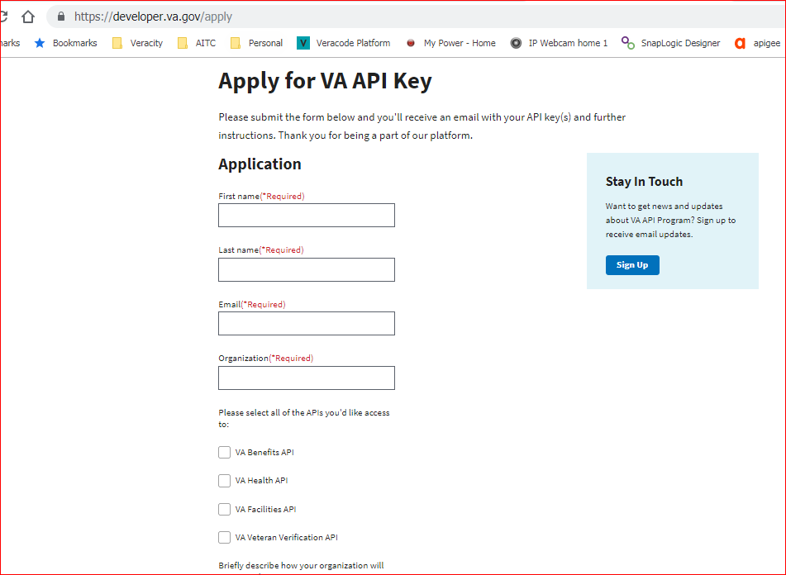

### Database Requirements

There is no database used for this application.

# Endpoints

The following details the requirements for the inputs and outputs of the service. There are three different endpoints available for use. They are listed below.

Kong-url:

* DEV: Dev (dev-api.va.gov):
* Staging (staging-api.va.gov):
* Prod (api.va.gov):

| Endpoint | Description |
| --- | --- |
| **Validate Address**  https://{{kong-url}}/services/address_validation/v1/validate | This service will accept an address; corrects and validates the given address. This service will return only one address. It will not correct all addresses, some will result in failures that cannot be fixed. |
| **Get City State Province**  https://{{kong-url}}/address/v1/addressDataService/getCityStateProvince/{postalCode}  **(US and Canada only)** | This service accepts a Canadian or US postal code and returns the city, state or province, country and city type. |
| **Candidate Address**  https://{{kong-url}}**/address/v1/candidate**  **(US and Canada only)** | This service accepts the same input as the address validation service. However, the candidate address endpoint will only return valid addresses and will return multiple matches if they exist. If the address validation endpoint is sent an address that returns multiple addresses, it will fail. |

# Address Validation

## Input

The input format is a JSON request. The fields are all strings.

### Fields

The fields accepted in the AVS are represented in an object as a request address.

**addressLine1, addressLine2, addressLine3**: The first 3 lines in the request address, these are solely for the purpose of the street address information. There should be no city, state, province or postal codes in these lines. This should contain only letters and numbers. One of these is required.

**addressPOU:** This is the Purpose Of Use of the address. If this field is “RESIDENCE/CHOICE” the address will fail if the Delivery Point validation (DPV) is returned as a value other than “CONFIRMED”.

**city:** The city of the requested address. This should contain only letters.

**internationalPostalCode**: The postal code for an international address only. This can contain letters and numbers.

**requestCountry:** An object that uses either a country code or name. There should only be one of these in the requested address

**countryCode:** The ISO2, ISO3, or FIPS country code for a country. This should contain only letters and be between 2 and 3 characters.

**countryName**: The name of the requested country. If the address is military or a territory of the United States, the country should be the United States

**stateProvince**: This field is the state or province for international or domestic addresses.

**code**: the 2-digit code for the state or province of an address.

**name**: the name for the state or province of the requested address

**zipCode5**: For military or domestic addresses. The 5-digit postal code. This should be only numbers.

**zipCode4**: For military or domestic addresses. The 4-digit add on to the postal code. This should be only numbers.

**addressPOU:** This field is optional, but the values should be either RESIDENCE/CHOICE, or CORRESPONDENCE entering a POU of CORRESPONDENCE will result in enabling DPV validation

### Input Requirements

The minimum required fields for the service are one of the following fields:

* Address Line 1
* Address Line 2
* Address Line 3

 And one of the following fields:

* country

## Output

The output is a JSON response, for samples and definitions please see the Swagger documentations

### Error Messages

This information is found in the Swagger documentation mentioned above. The messages can also be found at this address:

<https://developer.va.gov/explore/veteran_verification/docs/swagger/address-v1-msg-keys.html>

Errors can be returned if:

* The request address is not formatted correctly
* The request address is too long
* The address is not found or recognized
* The address would fail the rules of Vet360 validation
* The address is a non-valid dual address

### Missing Reference Data

There is a specific error ADDR207 for missing reference data. This is for international addresses that the AVS does not have the sufficient data to perform the necessary validations. The error message will specify whether the data for the street, postal code etc. is missing.

# GetCityStateProvince

This is an endpoint that returns the city, state or province, country and postal code ~~type~~ for the postal code given. *US and Canada only.*

## Input

The endpoint only accepts one US or Canadian postal code.

## Output

The specific format of the output will be in the Swagger documentation mentioned above.

The field “cityType” is the USPS® standardized city name type (U.S. addresses only) and has the following values:

| Endpoint | Description |
| --- | --- |
| **V** | Vanity (non-mailing) city name |
| **P** | Primary. The city name is the primary mailing city name. |
| **S** | Secondary. The city name is an alternate city name but is acceptable. A city can have multiple secondary city names. |

### Error Messages

Currently there is one error message directly related to the input service: Postal Code entered could not be found. There is also a possibility of the country lookup service being unavailable. More detailed information can also be found in Swagger.

# Candidate Address

This is an endpoint that returns a list of valid addresses for the input given. *US and Canada only.*

## Input

This endpoint has the same input and requirements as the section above.

## Output

This endpoint will return the same formatted output as the Address validation endpoint. However, this endpoint can return a list of addresses or no addresses if no match is found. All addresses that are returned from this service will validate when submitted to the proper Vet360 endpoints for updating an address.

### Error Messages

This information is found in the Swagger documentation mentioned above. The messages can also be found at this address:

<https://developer.va.gov/explore/veteran_verification/docs/swagger/address-v1-msg-keys.html>

# Additional Information

There are some specific fields and language in the AVS output, below are more in-depth explanations. For more information, please see the Pitney Bowes documentation referenced in this section.

## Vet360 Address Validation Rules

There are 3 message keys that begin with ADDR instead of ADDRVAL. These error codes indicate extra rules placed on the data by Vet360 validation. Any address sent to the AVS that returns any errors from the service will be sent to the Vet360 exception queue and not sent to other VA systems. To pass the Vet360 specific rules an address:

* Must have a confidence score over 80
* Must not have any additional postal information
* Must have a DPV of “CONFIRMED” if the addressPOU is CORRESPONDENCE

## Address Override Indicator

Many VA systems have the ability to verify, validate and standardize addresses via Coding Accuracy Support System (CASS) certified software. However, there are instances where an entered address does not pass the validation rules yet is still considered to be accurate and valid for that Veteran. These instances can be caused, for example, when an address is newer than that in the CASS software or in regions where address data is less accurate. When these instances occur, systems allow the address to be accepted despite the lack of address validation. At acceptance, an Address Override Indicator is set indicate that the validation has been overridden.

### Process Flow for an Override

In order for Vet360 to accept an override indicator, the address must first attempt to be validated. This attempt is checked by the field “validationKey” this is returned in the addressMetaData object of the response from the AVS.

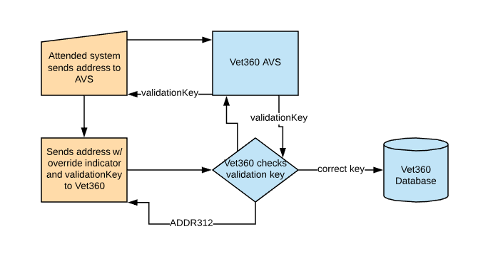

**Figure: Process flow for an address to be overridden**

In the figure above, the orange (two left-most boxes) indicates actions taken by a partner and the blue (three right-most boxes) indicates action performed by Vet360. To begin an address override, a partnering system will call the AVS service. In the addressMetaData response object, there is a field, “validationKey”. This key is unique for all addresses.

*For more information on the exact behaviors of the key returned, see the scenarios in the* [*Address Validation Service Feature Files*](https://github.com/department-of-veterans-affairs/vet360-address-validation-service/blob/development/vet360-address-validation-service-server/src/main/resources/static/features/adapter/addressValidation.feature) *mentioned in section 1.1.2.*

After the validationKey is received, it must be passed to the Vet360 service as part of the addressBio. Vet360 will confirm the validation key by sending it to the AVS and comparing the values. If the key matches, the address will be sent to the Vet360 database and shared with partners. If the key does not match or is missing, the address will be rejected with the error code ADDR312: The address override criteria has not been met, please attempt validation again.

**Note:** The process above assumes that all other aspects of the address are valid. All necessary fields are populated and contain the correct data types. The override is for validation and standardization by the AVS only and will not account for special characters, missing required fields, etc.

## Location Precision

|  |  |  |
| --- | --- | --- |
| **Location Precision Value** | **Vet360 Mapping** | **Description** |
| **Domestic** |  |  |
| **ADDRESS** | 31 | An array of street segment points representing the street segment where the address is located. |
| **INTERSECTION** | 30 | A geocode point for the intersection of two streets. |
| **POSTAL1** | 33 | A geocode point for the ZIP centroid. |
| **POSTAL2** | 34 | An array of points for all street segments in the ZIP + 2 in which the address is located. |
| **POSTAL3** | 35 | An array of points for street segments in the ZIP + 4 in which the address is located |
| **ERROR** | 36 |  |
| **Global** |  |  |
| **0** | 0 | No coordinate information is available for this candidate address. |
| **1** | 1 | Interpolated street address |
| **2** | 2 | Street segment midpoint. |
| **3** | 3 | Postal code 1 centroid. |
| **4** | 4 | Partial postal code 2 centroid. |
| **5** | 5 | Postal code 2 centroid. |
| **6** | 6 | Intersection. |
| **7** | 7 | Point of interest. |
| **8** | 8 | State/province centroid. |
| **9** | 9 | County centroid. |
| **10** | 10 | City centroid. |
| **11** | 11 | Locality centroid. |
| **Null** |  |  |

## Delivery Point Validation (DPV)

DPV is a United States Postal Service (USPS) technology that validates the accuracy of address information down to the individual mailing address. By using DPV® to validate addresses, you can reduce undeliverable-as-addressed (UAA) mail, thereby reducing postage costs and other business costs associated with inaccurate address information.

**Note: DPV® is only available for U.S. addresses.**

Without DPV, the address validation process only verifies that an individual address is within a range of valid addresses for the given street. For example, the USPS data indicates that the range of addresses on Maple Lane is 500 to 1000. You attempt to validate an address of 610 Maple Ln. Without DPV, this address would appear to be valid because it is in the range of 500 to 1000. However, in reality the address 610 Maple Ln does not exist: the house numbers in this section of the street are 608, 609, 613, and 616. With DPV processing, you would be alerted to the fact that 610 Maple Ln does not exist, and you could take action to correct the address.

DPV also provides unique address attributes to help produce more targeted mailing lists. For example, DPV can indicate if a location is vacant and can identify commercial mail receiving agencies (CMRAs) and private mail boxes.

Although DPV can validate the accuracy of an existing address, you cannot use DPV to create address lists. For example, you can validate that 123 Elm Street Apartment 6 exists, but you cannot ask if there is an Apartment 7 at the same street address. To prevent the generation of address lists, the DPV database contains false positive records. False positive records are artificially manufactured addresses that reside in a false positive table. For each negative response that occurs in a DPV query, a query is made to the false positive table. A match to this table will stop DPV processing. Please see the table below for an explanation of the values returned

|  |  |
| --- | --- |
| **Value Returned from AVS** | **Description** |
| CONFIRMED | DPV confirmed. Mail can be delivered to the address. |
| STREET_NUMBER_VALIDATED_  BUT_MISSING_UNIT_NUMBER | The building number was validated but the unit number was missing from input. A building number is the primary address number for a building. A unit number is a number of a distinct mailing address within a building such as an apartment, suite, floor, and so on. For example, in this address 424 is the building number and 12 is the unit number:  424 Washington Blvd. Apt. 12  Oak Park IL 60302  USA |
| STREET_NUMBER_VALIDATED_  BUT_BAD_UNIT_NUMBER | The building number was validated but the unit number was missing from input. A building number is the primary address number for a building. A unit number is a number of a distinct mailing address within a building such as an apartment, suite, floor, and so on. For example, in this address 424 is the building number and 12 is the unit number:  424 Washington Blvd. Apt. 12  Oak Park IL 60302  USA |
| MULTIPLE_MATCHES_FOUND | The address matches multiple valid delivery points. |
| UNDELIVERABLE | Mail cannot be delivered to the address. |
| MISSING_ZIP | The address could not be confirmed because the address did not code at the ZIP + 4 level. |
| FALSE_POSITIVE | The address caused a false-positive violation. |

## Dual Addresses

The Vet360 AVS will handle dual addresses in a specific way. The PO box will be returned on the second line, and the street address will be returned on the first line. A dual address that does not have a PO box in the same zip code as the street address will not pass validation. Please refer to the USPS documentation on dual addresses [here](https://pe.usps.com/text/pub28/28c2_005.htm) for more information.

# Support

For issues experienced with the AVS, please create a Service Now ticket using: <https://yourit.va.gov/va>

1. Assign this ticket to **EPMO.V36 Application Administrators**
2. Use a format VET360 – Address Validation – [Issue/Error Summary]
3. Please use specific language and screenshots if applicable in your tickets. This will assure your issue gets handled as quickly as possible